Fraction

* Part of a whole
* Parts must all be same size

|  |  |  |  |
| --- | --- | --- | --- |
|  |  |  |  |

$\frac{3}{4}$

Denominator

* Bottom part
* Total number of equal parts in a whole

Numerator

* Top part
* Number of pieces selected, eaten, shaded, used, chosen…

Equivalent fractions

* Same amount selected, eaten, shaded, used, chosen
* Doesn’t need to be same number of parts
* Two or more fractions that name the same part of a whole

|  |  |
| --- | --- |
|  |  |
|  |  |

|  |  |
| --- | --- |
|  |  |

=

Models:

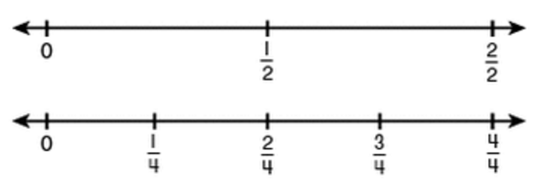

Number Line:

(Equivalent Fractions) Whole numbers as a fraction:

* Any number with one as the denominator equals a whole: $\frac{2}{1}$ = 2, $\frac{3}{1}$ = 3, $\frac{4}{1}$ = 4
* The fraction bar is a division sign: $\frac{4}{2}$ = 2, $\frac{8}{4}$ = 2, $\frac{6}{2}$ = 3

Comparing fractions (greater than, less than, equal to)

* Must compare using the same size wholes

|  |  |
| --- | --- |
| When the numerators of the two fractions are the same… | …compare the denominators.  ex: Compare  and   * The **smaller** denominator means that there are fewer pieces in the whole, so the pieces must be **larger**. * Since the **number** of pieces is the same, (both fractions are talking about 3 pieces out of the whole), then the smaller the denominator, the larger the fraction. * is greater than (>) because three of the larger pieces (fifths) is more than three of the smaller pieces (eighths). |
| When the denominators are the same… | …compare the numerators.  ex: Compare  and   * Since the denominators are the same, the pieces are all the same size. * The larger numerator indicates more pieces, so the larger the numerator, the larger the fraction. * is greater than (>). |
| Compare fractions to benchmarks | Compare fractions to 0, ½, and 1.   * If one of the fractions is less than ½, and one of the fractions is greater than ½, then you are done. |